**Nick D’Aloisio**

Nick D’Aloisio is a 21-year-old computer engineer and internet entrepreneur. He was born in London, England and educated in King’s College School. D’Aloisio is a young, gifted software developer who at the age of 17 became one of the youngest self-made millionaires.

D'Aloisio is the creator of Summly, an automatic summarization algorithm, developed with the help of SRI International (Stanford Research Institute). He has been recognised as the youngest person to receive a round of [venture capital](https://en.wikipedia.org/wiki/Venture_capital) in technology, at just 15 years of age.

In 2013, D’Aloisio sold Summly to Yahoo for a reported US$30 million. He has received many awards for his work with Yahoo and in the tech industry such as "Innovator of the Year" in New York City by the Wall Street Journal. He was also included in TIME Magazines ‘TIME 100’ as one of ‘The World’s most Influential Teenagers’.

**Why I picked Nick?**

I picked Nick D’Aloisio as an influential software engineer because the success he has achieved at such a young age is inspiring. He is the same age as myself which makes it even more mind blowing that he founded and created such a well-developed and engineered application.

D’Aloisio also stood out to me as an influential engineer because of his drive and belief in himself. In March 2011, Nick created the initial IOS ‘Trimmit’, which was an analytical tool to mass condense content into short summaries. After creating the initial app, he successfully attracted the attention of a billionaire who provided him with funding.

D’Aloisio also managed to pitch his venture to several celebrities like Rupert Murdoch, Ashton Kutcher, and Stephen Fry which allowed him to raise funds of close to $1.25 million.

**What is ‘Summly’?**

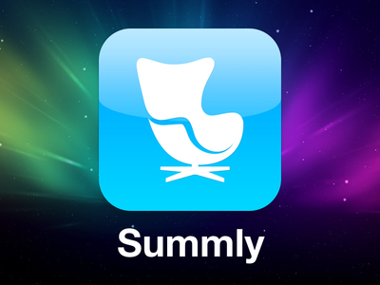D’Aloisio created an iPhone app called ‘Summly’, which summaries content like news stories into only a few sentences so that the reader can understand the gist of the story without reading hundreds of words. The app was downloaded by nearly a million people. His idea was to target the “generation of skimmers”. On the Summly website D’Aloisio talks about how the app works:

“While we started with a relatively simple extraction algorithm for general news, we have now launched a bold and ambitious effort to take summarisation technology far beyond its present state. Our in-house research makes innovative use of machine learning and natural language processing, using evaluation metrics that show our technology to be highly effective.”

The automatic summarization algorithm, developed with SRI, condenses content from multiple sources down to 1000,500,140-character text.

‘Summly’ aimed to solve perceived problems with the way news articles are presented on smartphones and therefore making it easier for readers to consume information. It allows users to browse hundreds of sources and news documents efficiently and is available on multiple platforms.

**How Nick achieved such success?**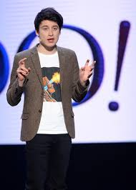

Nick achieved success from a very young age. In early 2008, when the Apple App Store was announced, 12-year-old D’Aloisio realised it was a huge opportunity. He taught himself basic programming using open-source software online and the book C for Dummies. When he launched his first app, a jokey app called [FingerMill](http://www.youtube.com/watch?v=1b0lnFMFNU0) (a treadmill for fingers), in August 2008, a month after the store opened, it made £79 on the first day. He also created a free app called TouchWood (made the screen look like wood and made a sound when you knocked on it). It was gimmicky. But every time he made an app he learned more. The passion and drive he had at such a young age paved the way for his later successful ventures.

In March 2011, Nick created the IOS app ‘Trimmit’, which used an automatic summarization algorithm to condense stories. Th application caught the attention of Apple, who then featured it as a new noteworthy application on the App store. This started the ball rolling for Nicks success.

The huge potential of Trimmit then attracted the attention of a billionaire who provided Nick with $300,000 in venture capital funding. Using this funding and feedback he has gotten Nick completely revamped the application and re-launched it as Summly.  
Nick is the world’s youngest venture capital-backed entrepreneur. In 2011, he initially raised $200,000 in seed funding from the Hong Kong billionaire Sir Li Ka-shing’s Horizon Ventures for his app. Later in 2012, he went on to raise a good $1.23 million from various A-list celebrity investors like Rupert Murdoch, Ashton Kutcher, and Stephen Fry.   
  
Then in March 2013, Yahoo! Announced they had bought Summly for US$30 million. D’Aloisio went on to be awarded the “[Innovator of the Year](http://valleywag.gawker.com/wsj-names-teen-brat-millionaire-technology-innovator-1461024632)” title by Wall Street Journal.

**What is Nick D’Aloisio up to now?**

After the acquisition, D’Aloisio began working for Yahoo to help develop Yahoo News Digest, which used both algorithms and human editorial judgment to pick out stories from online publications.

D’Aloisio is currently studying computer programming and philosophy in Oxford University. Up until Summer 2015, Nick worked as Product Manager for Yahoos News Digest application. Impressively, he has produced five academic papers under review at various philosophy and cognitive science journals, several of which have been published.

A new app is in the works as Nick has raised funding for a new stealthy start-up that promises to help you find and instantly chat to an expert on a range of topics.

